Supplemental Report: Comparing 64” Xyphose to 60” Xyphose
This report is intended to directly compare the performance and shootability of a 64” Bushmen Xyphose to a 60” Bushmen Xyphose. During many discussions with the bowyer, we theorized that my shorter draw length of 27.75” may not be opening the limbs of the 64” bow completely and therefore I was sacrificing performance. We both believed that I would likely gain speed and additional performance aspects from a shorter bow but questioned if I would have to sacrifice the shootability of the bow to gain the performance. The only way to answer the questions was to obtain a Xyphose of shorter length, evaluate it in the same manner as the 64” Xyphose and compare the data.
As a reminder to those who read my first evaluation or as an introduction to those who did not see that document, I evaluated the Xyphose using three criteria. Performance, shootability and craftsmanship. In this evaluation we need not address craftsmanship as the quality and beauty of Steve’s work is not in question. In this document I will provide data that addresses performance differences between the two bows as well as my subjective evaluation of shootability. With that said, again, in the past 2 years I have owned and shot more than 25 different bows (recurves and longbows), nearly all of them in the $1200 and up price range. Therefore, I would consider my observations to perhaps be less qualified than a few other archers, but probably more qualified than the average. When it comes to the subjectivity of the forgiveness and tunability of the bow, your mileage may vary.
For the data evaluation of this report, I marked all arrows and made sure to draw them to exactly 28” even though my draw length is only 27.75”. For the purposes of data evaluation, I wanted to remove as many variables as possible. As such, some of the speed data may not exactly match the initial report. There was very little difference in the speed data, but it is not an exact match. As such the data in this report should be taken separately from the original report.

Performance:
For the performance portion of the evaluation, I again measured speed and cast as the primary considerations but also added kinetic energy. Drawing at 28” the 64” bow measured 50.05# and the 60” bow measured 45.72# on my scale. While the bow was 4” shorter it was also 4.3# lighter in draw weight.
Just as the previous speed evaluation, I shot arrows of 9.0, 10.0, 11.0, 12.0 and 13.0 grains of arrow weight per pound of draw for both bows. The graph below illustrates the data collected.
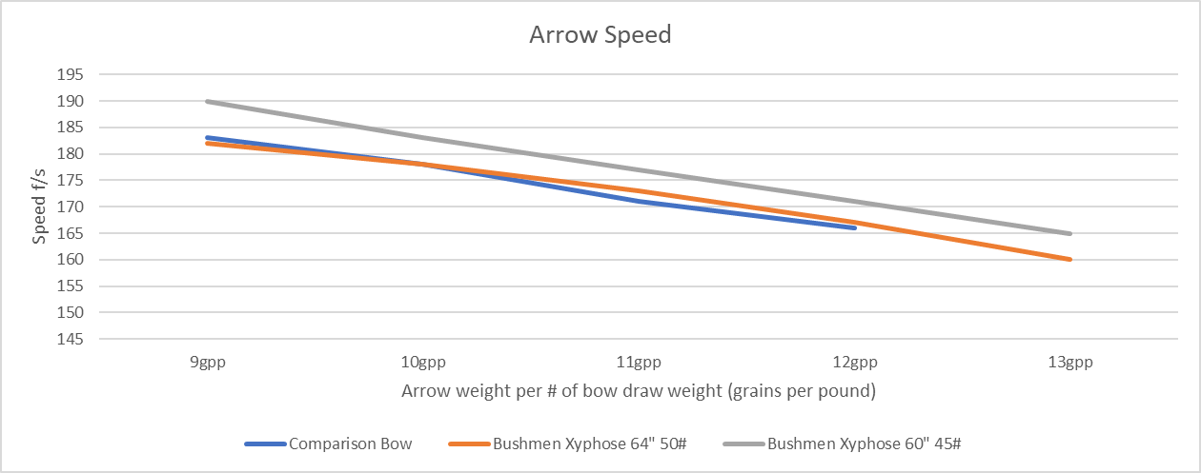

As you can see from the graph, the shorter bow was on average 5-6 fps faster than the longer bow despite being more than 4# lighter. As a reminder the comparison bow from the previous report was a 58” 45.25# “performance” recurve. In this regard, the shorter bow lived up to my expectations. I anticipated it would be faster at equivalent arrow weights when normalized to grains per pound and it certainly was. I have only ever had one other bow exceed 190fps and I found it to be wild and unshootable. I wanted to test the limits of the bow, so with the bowyer’s permission I built an arrow at 8gpp hoping to see a 200fps reading on the chronograph. It would certainly be a first for me…but it was not meant to be. 8gpp – 28” draw – 196fps. Still quite fast by any comparison.
Because I am primarily focused on hunting, I wanted to know how much kinetic energy I was sacrificing to shoot a shorter but lighter bow. The graph below illustrates the difference in kinetic energy between the two bows at equivalent grains per pound of arrow weight.
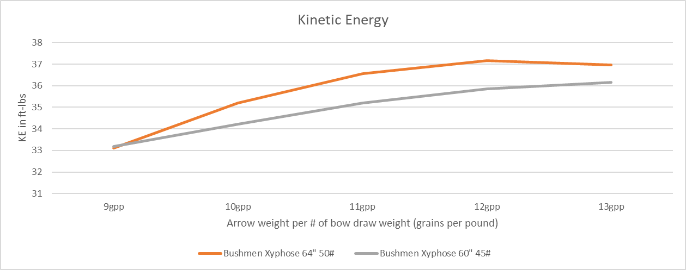
I also used this data to select the arrow weights I would shoot out of these bows. For obvious reasons I settled in on just shy of 12gpp as that is where kinetic energy is optimized. You can see from the graph that despite being more than 4# lighter in draw weight, the difference in KE between the bows is just over 1ft-lb of energy. For my thinking, that is very little sacrifice in power to be able to hunt with a bow that draws much easier in cold weather when joints are stiff.
Finally, just as with the previous evaluation I measured the cast of the bows because, well again, sight picture matters.
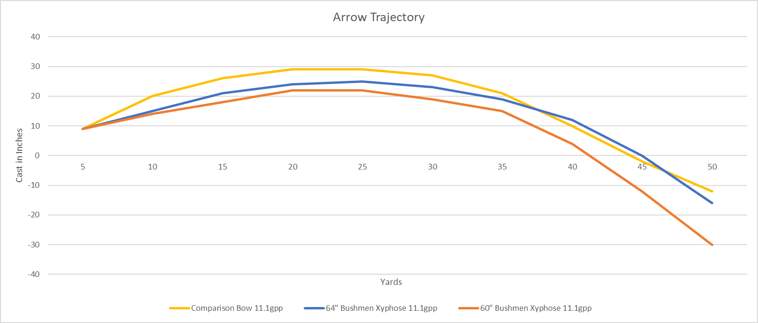
As expected, because the arrows are faster the cast is flatter for the shorter bow. For me, this translates into a sight picture that is preferred at shorter distances (inside of 35 yards).
Shootability/Tuning:
There are a number of factors that I evaluated when I considered shootability and most of them are qualitative. The qualitative aspects that I considered were noise, hand shock, ease of tune and impact of form change on shot quality. The exception and only quantitative consideration was draw cycle. Just as with the 64” bow, the draw was smooth and consistent. There was no noticeable stacking of the 60” bow out to 30” which should be the max draw length for this bow. 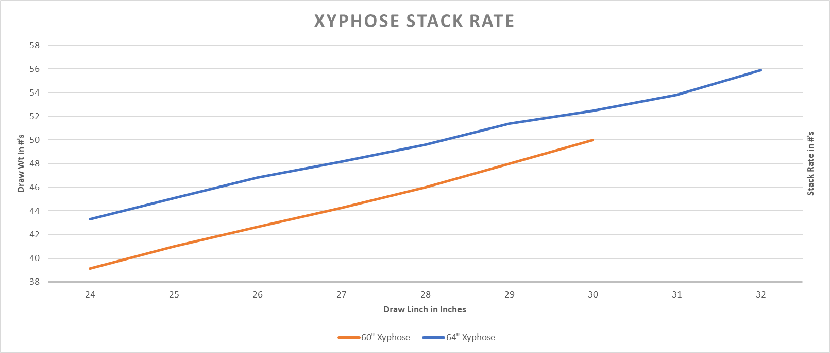
I shot both bows with no quivers at 11.1gpp arrows to compare noise and hand shock. There was no noticeable difference in noise between the two bows to myself or other observers I had standing at various locations around me listening. I had anticipated the shorter bow might be louder with more hand shock, so I was quite pleased when that was not the case. The Xyphose is without a doubt one of the quietest bows I have ever shot. An interesting side note: The bow went from quiet to silent if I changed from 3-under to split finger. Individuals standing within 8 feet of me could not hear the bow when I released. Regarding hand shock, the only thing I could feel in either bow was a very minor string buzz for about half a second. Certainly, less than I hear with many other bows I have shot.
I did notice a slight difference between the bows regarding arrow selection and tuning. Recall from the first evaluation that the 64” bow would shoot various arrow spines and point weights relatively well. Just as before, I relied on bare shaft tuning at 30 yards and 40 yards to be the measuring stick of how accepting each bow was of varying spines and point weights. In general, the 60” bow is still easy to tune when compared to many other bows I have owned, but it was a bit more finicky than the 64”. Both bows are very accepting of arrows that shoot weak…meaning very weak arrows only shoot slightly off from arrows that are slightly weak. The 64” bow was just as accepting of stiff arrows where the 60” bow was accepting of slightly stiff arrows but didn’t have as much tolerance for arrows that were considerably too stiff. An interesting phenomenon that may one day warrant further investigation.
Regarding the forgiveness of the bow, I am speaking of the impact of poor form or a poor release on the arrow placement down range. On more than one occasion with the 64” Xyphose I have called an arrow “out” upon release only to have it hit the 8” paper plate that was my target at 40 yards. In the limited 300 arrows I have shot from the 60” bow I have found it to be much more accommodating to poor shots than many bows I have owned, but it is slightly less forgiving than the 64” Xyphose. Perhaps with more time I may find them to be equal. In the meantime, at 30 yards and closer while the groups may be slightly tighter with the 64”, the animal will never know the difference.
Conclusions:
If I was a target shooter, I would likely opt for the 64” bow if only because my down range confidence in it is extremely high. However, as a hunter the 60” bow is an easy choice. The gains in speed, sight picture and lighter draw weight far outweigh the minimal loss in kinetic energy and forgiveness of the bow at ranges I would never hunt at. Perhaps the 62” bow would be the perfect bow for me and I will probably buy one and test that theory later this spring. For now, I am happy to shoot the 60” bow as my primary hunting, 3D and target rig.
Focusing on hunting I suspect the 60” bow will be ideal for draws 28” and under. Draws above 28” to 30” will probably chose the 62” bow and those hunters lucky enough to have a draw over 30” should opt for the 64”. If you are going to shoot 3D, everyone under 30” will probably prefer the 62”. For target only, the 64” bow is going to be hard to beat regardless of your draw length.
If you have the chance to shoot one, I highly recommend you do so…but only if you have the money to buy one because you are going to be disappointed in most of your other bows.

